Term: Autumn 2 | Year: 2024 | Teachers: Mrs Baines, Miss Langdon, Miss Tansley and Mr Daysh | Year group: 3 and 4
PHSE
Valuing differences

Art
Drawing
Gestural drawing with charcoal
Artists: Laura McKendry, Edgar Degas
Cave paintings

P.E
Gymnastics.
Invasion games
Swimming

Computing
Branching databases

Religious Education
Judaism
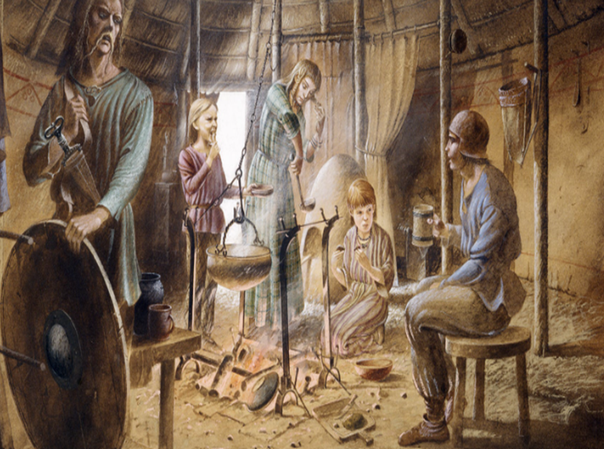

History
Bronze Age to Iron Age

English (including Punctuation, Spelling and Grammar)

In English, we will complete ‘The Place Value of Punctuation and Grammar’ unit. Within this unit we will master and consolidate our knowledge of sentence structure, word class and how to produce accurate and effective extended writing.
We will apply this into our writing to produce a non-chronological report prehistoric animals.

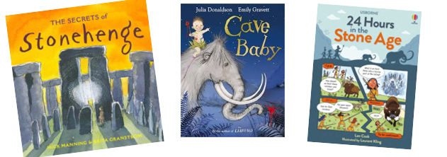

Bronze Age to Iron Age

Music

Christmas production songs

Science
Animals Including Humans

How does our skeleton help us?

Do our bones affect what we can do?

What do our muscles do?

Do all animals have the same skeleton?

What types of nutrition do we need?

Wilhelm Roentgen, physicist

Mathematics
YR3

YR4

